PT INDO AMERICAN SEAFOODS Tbk  DAN ENTITAS ANAK  LAPORAN POSISI KEUANGAN  KONSOLIDASIAN  Tanggal 31 Desember 2024 dan 2023  (Disajikan dalam Rupiah Penuh,  kecuali Dinyatakan Lain) | PT INDO AMERICAN SEAFOODS Tbk  AND SUBSIDIARY  CONSOLIDATED STATEMENTS OF  FINANCIAL POSITION  as at December 31, 2024 and 2023  (Expressed in Full of Rupiah,  unless Otherwise Stated)

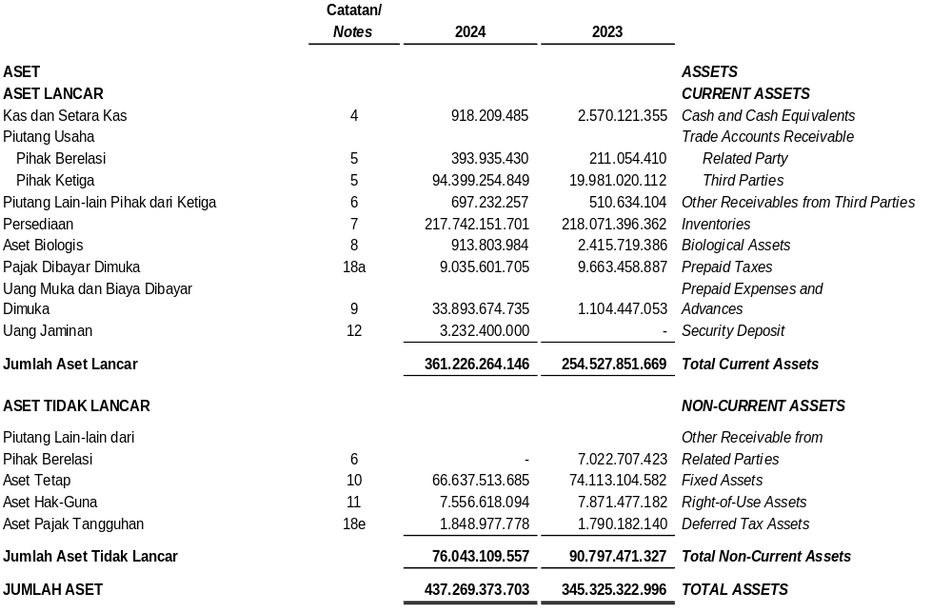

PT INDO AMERICAN SEAFOODS Tbk  DAN ENTITAS ANAK  LAPORAN POSISI KEUANGAN  KONSOLIDASIAN (Lanjutan)  Tanggal 31 Desember 2024 dan 2023  (Disajikan dalam Rupiah Penuh,  kecuali Dinyatakan Lain) | PT INDO AMERICAN SEAFOODS Tbk  AND SUBSIDIARY  CONSOLIDATED STATEMENTS OF  FINANCIAL POSITION (Continued)  as at December 31, 2024 and 2023  (Expressed in Full of Rupiah,  unless Otherwise Stated)

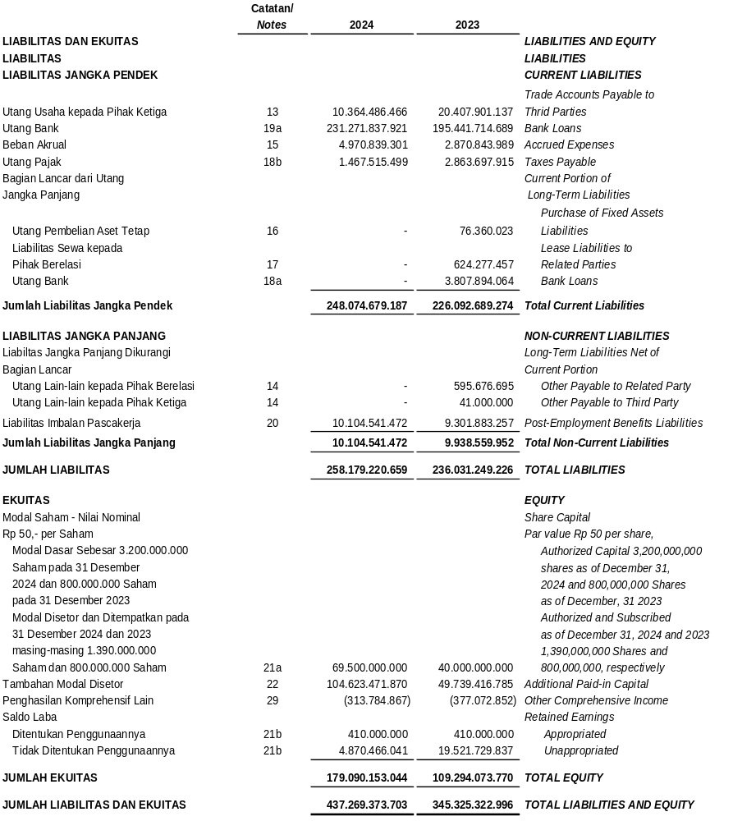

PT INDO AMERICAN SEAFOODS Tbk  DAN ENTITAS ANAK  LAPORAN LABA RUGI DAN  PENGHASILAN KOMPREHENSIF LAIN  KONSOLIDASIAN  Untuk Tahun-tahun yang Berakhir pada  Tanggal 31 Desember 2024 and 2023  (Disajikan dalam Rupiah, kecuali Dinyatakan Lain) | PT INDO AMERICAN SEAFOODS Tbk  AND SUBSIDIARY  CONSOLIDATED STATEMENTS  OF PROFIT OR LOSS AND  OTHER COMPREHENSIVE INCOME  For the Years Ended  as at December 31, 2024 and 2023  (Expressed in Rupiah, unless Otherwise Stated)

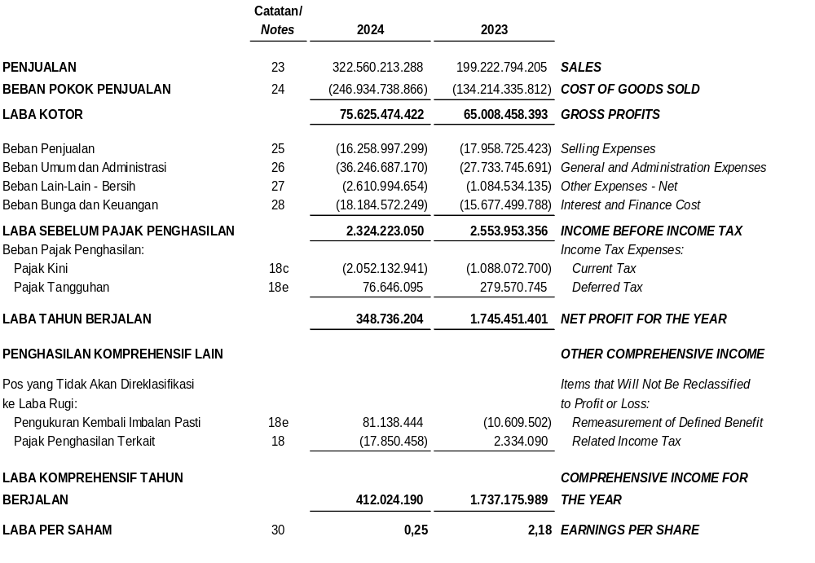

PT INDO AMERICAN SEAFOODS Tbk DAN ENTITAS ANAK  LAPORAN PERUBAHAN EKUITAS KONSOLIDASIAN  Untuk Tahun-Tahun yang Berakhir Tanggal 31 Desember 2024 and 2023  (Disajikan dalam Rupiah Penuh, kecuali Dinyatakan Lain) | PT INDO AMERICAN SEAFOODS Tbk AND SUBSIDIARY  CONSOLIDATED STATEMENTS OF CHANGES IN EQUITY  For the Years Ended as at December 31, 2024 and 2023  (Expressed in Full of Rupiah, unless Otherwise Stated)

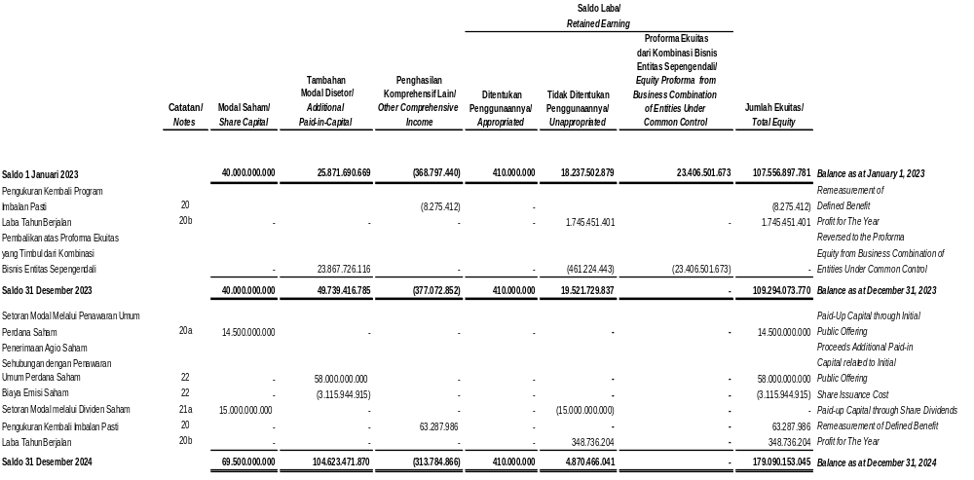

PT INDO AMERICAN SEAFOODS Tbk  DAN ENTITAS ANAK  LAPORAN ARUS KAS  KONSOLIDASIAN  Untuk Tahun-Tahun yang Berakhir  Tanggal 31 Desember 2024 and 2023  (Disajikan dalam Rupiah Penuh,  kecuali Dinyatakan Lain | PT INDO AMERICAN SEAFOODS Tbk  AND SUBSIDIARY  CONSOLIDATED STATEMENTS  OF CASH FLOWS  For the Years Ended  as at December 31, 2024 and 2023  (Expressed in Full of Rupiah,  unless Otherwise Stated)

